

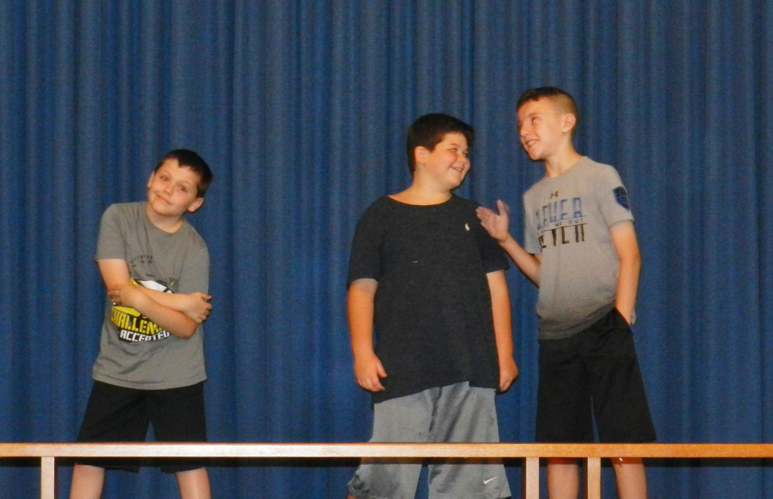

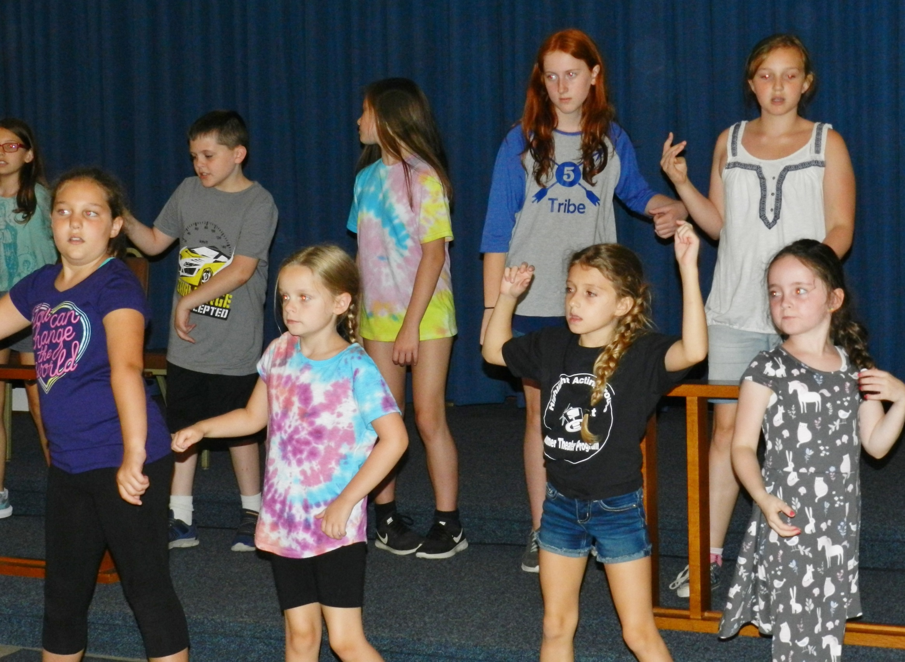

### The Highlight Acting Troupe is a community theater organization dedicated to providing opportunities in the performing arts through performance, education and awareness.

### 

**Highlight Acting Troupe**





**Summer Theater Program**

#### For information call

***Ethel – 518-237-6936***

#### Ethel—237-6936

**July 8 – 19, 2019**

**Highlight Acting Troupe**

Center Brunswick United Methodist Church

Rt. 7

Troy, NY

July 8-19, 2019

**HAT Board of Directors**

A.J. Printsky Chairman

Heidi Flatt Vice Chairman

Ethel LeVan Treasurer

Paula Hoffay Secretary

Christine LeVan Publicity

Member at Large

Robin Dickinson-Sawyer

**HAT Officers**

Mark Strock President

Steve Salhoff Vice President

**Daily Activities**

**8:30 – 9:00 am Arrival**

**Opening Games**

**9:10-10:00 am 1st. session**

**10:10-11:00 am 2nd. session**

**11:10-12 noon 3rd. session**

**12:00 Noon Lunch and Outdoor Activities**

**1:30 pm Rehearsal for Performance**

**3:00pm Games**

**3:15 Get ready for dismissal**

**3:30 pm Children picked up**

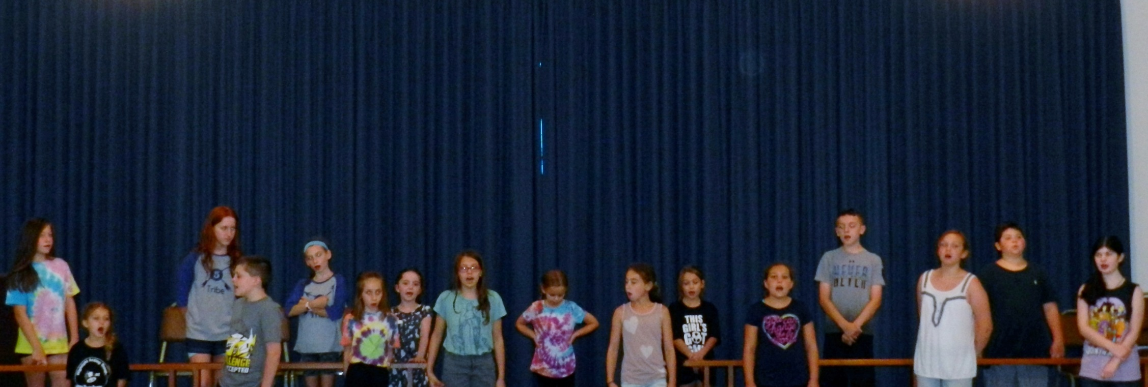

**Summer Theater Program**

**July 9-20, 2018**

Center Brunswick United Methodist Church

Rt. 7

Troy, NY

### Summer Staff

Program Coordinator Ethel LeVan

Acting Director McKenzie LeVan

Music Director Chris Morris

The Program is open to children between the ages of 6 (or completed Kindergarten) and 14. All children in the program will be involved in the performance on July 19.

To download a registration form you can go our website at Highlightacting.com or call Ethel at 518-237-6936 to have a form mailed to you or to answer any questions you may have.

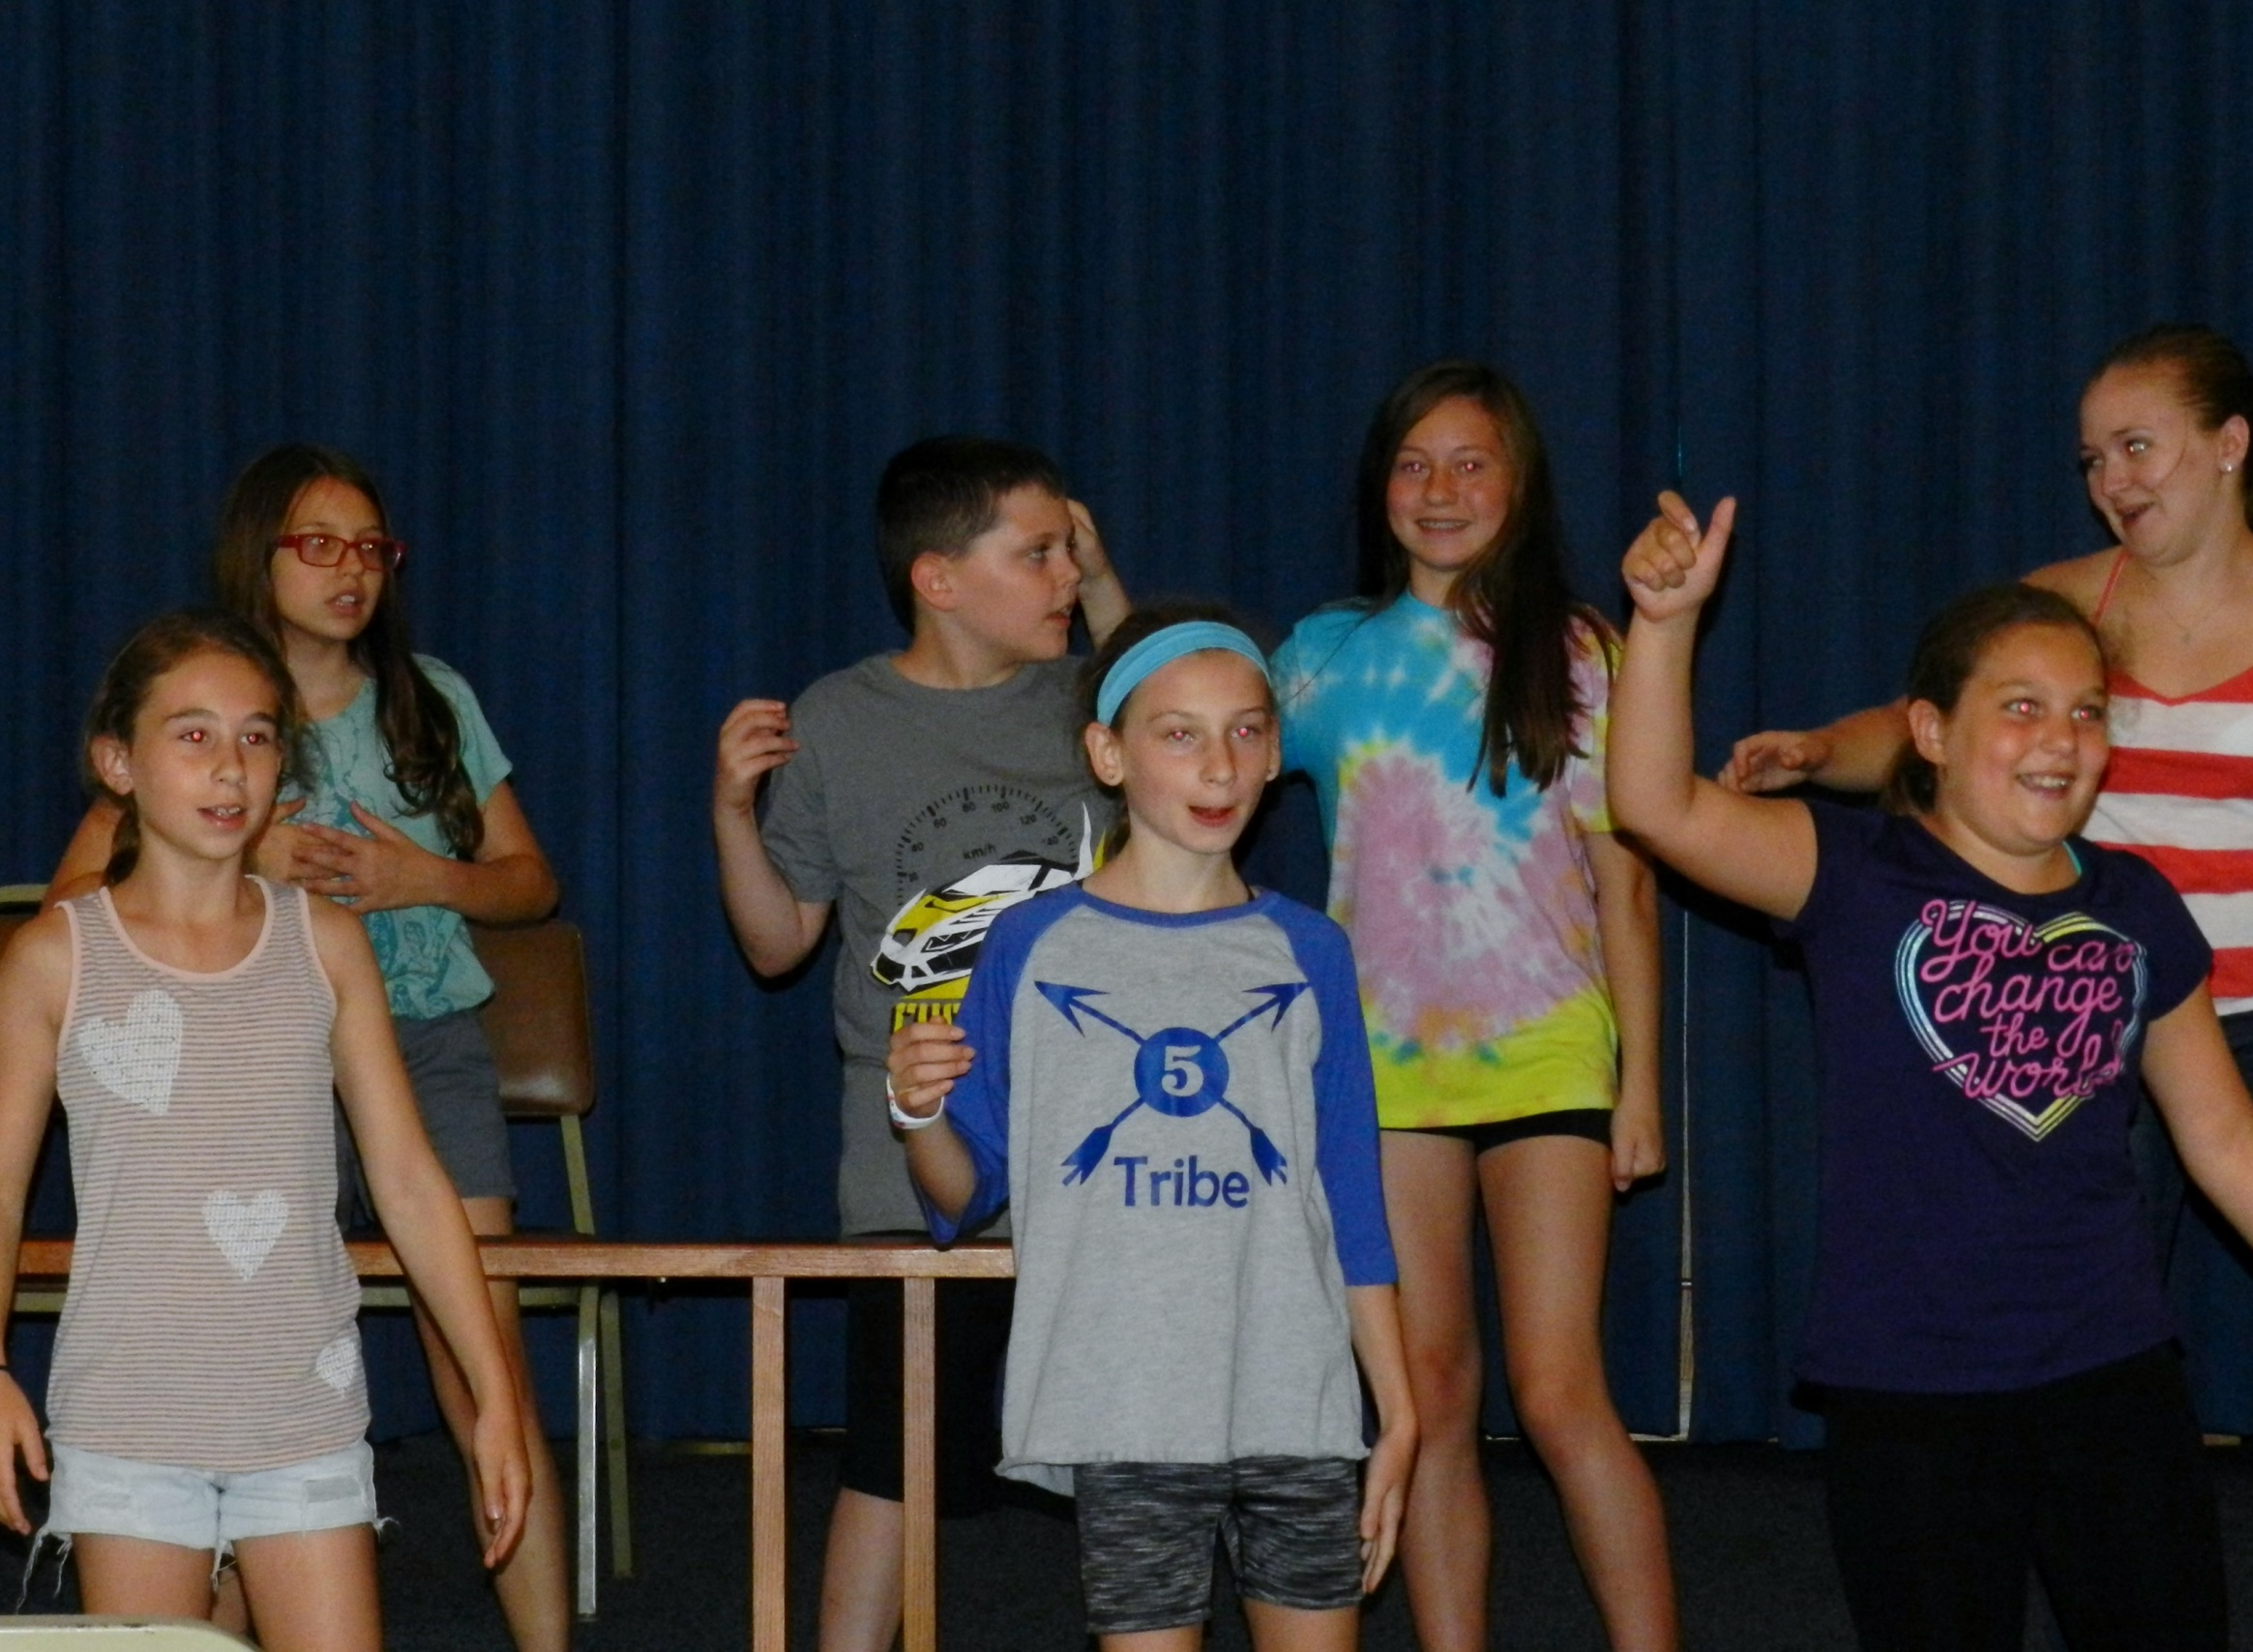

The summer theater program is a two week program beginning July 8 and ending July19. The program will start at 9:00 am and end at 3:30 pm. The cost for the program is $250.

The registration form and a deposit of $50 will be required by May 31, 2019 with the balance due by July 8, 2019. Make checks payable to Highlight Acting Troupe and mail to Ethel LeVan at 13 Norman Lane, Troy, NY 12182.

The daily activities will include acting, stage movement, choral and solo work, and backstage work. There will be time to go outside after lunch for games before the afternoon program begins.

Children should bring a bag lunch and beverages. We will have water available throughout the day.

On the last day of the program parents and families are invited in the afternoon to a performance by the children. The last two days of the program will be at the Brunswick Grange. Refreshments will follow the performance on Friday.